Case 2-A342-ME-Syro-Hittite-Astarte-Terracotta-Late Bronze Age-1500 - 1200 BCE

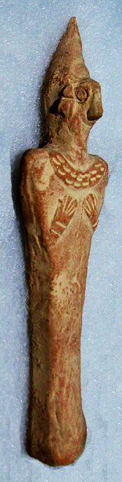 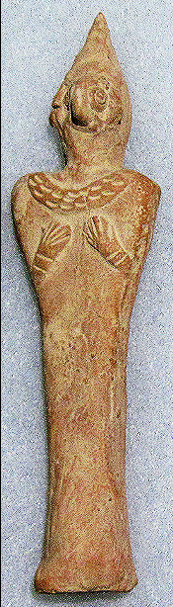 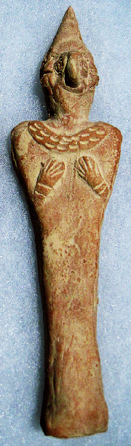 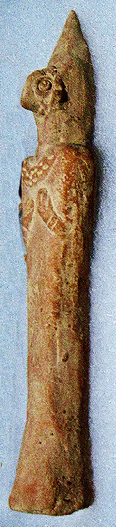

Figs. 1-4. Syro-Hittite-Astarte-Figurine-Terracotta-Late Bronze Age-1500 - 1200 BCE

**Case no.: 3**

**Accession Number: A342**

**Formal Label:** Syro-Hittite-Astarte-Figurine-Terracotta-Late Bronze Age-1500 - 1200 BCE

**Display Description:**

This stylized figurine with flat violin-shaped body and bird face with elaborate coiffure has two short arms pressed against the breasts. A very faint navel in the lower abdomen area. Incised design decorates the torque around the neck (cf. Spycket, A., Borowski Collection, 2000, Cat. no. 84, p. 102, (photograph, p. 101), for the type with long arms; Keel, O., Freiburg, 2008, p. 23, fig 3). The face is dominated by a raptorial beak suggestive of the practice of excarnation that takes place with the deceased at the scaffolding of the body.

**Date or Time Horizon:** Late Bronze Age-1500 - 1200 BCE

**Geographical Area:** N Syria, S Anatolia.

**Map, GPS coordinates:** N Syria, S Anatolia

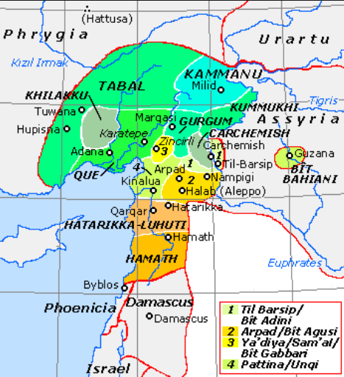

**Fig. 5.** Map of Luwian-, Aramaic- and Phoenician-speaking political entities of the the Syro-Hittite states in northern Syria and southern Anatolia from https://upload.wikimedia.org/wikipedia/commons/f/fe/NeoHittiteStates.gif.

**Cultural Affiliation:** Syro-Hittite

**Medium:** Terracotta

**Dimensions:** H. 13.4 cm, 5 1/4 in

**Weight: 93 gm, 3.25 oz**

**Condition:** Syro-Hittite

**Provenance:** Ex. Private Collection 1980's; Gideon Sasson, Sasson Ancient Art, King David Hotel - Annex, Jerusalem - 94101, Israel.

Discussion:

**References:**

Cornelius, Izak. 2004. *The many faces of the goddess: the iconography of the Syro-Palestinian goddesses Anat, Astarte, Qedeshe.* Fribourg, Switzerland: Academic Press; Göttingen: Vandenhoeck & Ruprecht.

Keel, O. 2008. *Gott weiblich: Eine verborgene Seite des biblischen Gottes, Gutersloher Verlagshaus*. Freiburg.

Spycket, A. 2000. *The Human Form Divine. From the Collection of Elie Borowski,* Exh. cat., Jerusalem: Bible Lands Museum.